Amazon Web Services

Snapshots

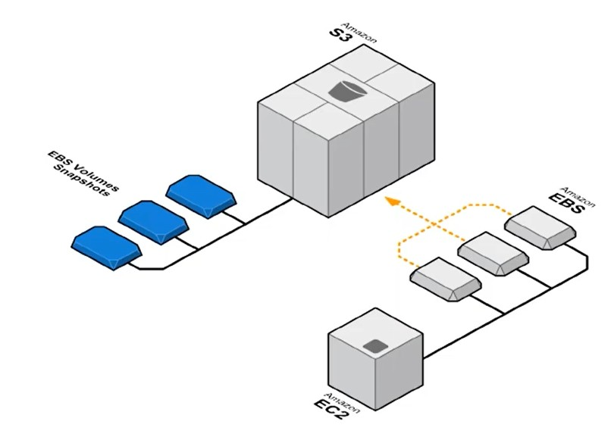
Amazon EBS Snapshots provide a simple and secure data protection solution that is designed to protect your block storage data such as EBS volumes, root volumes.

EBS Snapshots are a point in time copy of your data, and can be used to enable disaster recovery, migrate data across regions and accounts, and improve backup compliance. It is stored in Amazon S3.

- With the help of Snapshots we can move of disc from one region to another region.

- Create EC2 Machine in Mumbai Region

Add EBS Volume

- Launch the Instance

- Check Volumes

Elastic Block Store
Volumes

- Create Snapshot

- Select the Volume
Actions
Create Snapshot

- Enter the name of the snapshot

- Add the Tag

- Click on Create Snapshot

- Now check the snapshot
Elasitc Block Store
Snapshots
- Copy the Snapshot to another Region
Actions
Copy
- Select the Destination Region

- Click on Copy

- Now Change the region & Check the Snapshot

- Directly we can’t attach the snapshot to any of the instance.

- Convert Snapshot to Volume

Actions
Create Volume

- Click on Create Volume

- Now we can attach the Volume to any of the instance as per our
requirement.
Actions
Attach Volume

